Remote Online Educational Contest «BRAIN RING 2016 - Winter Session»
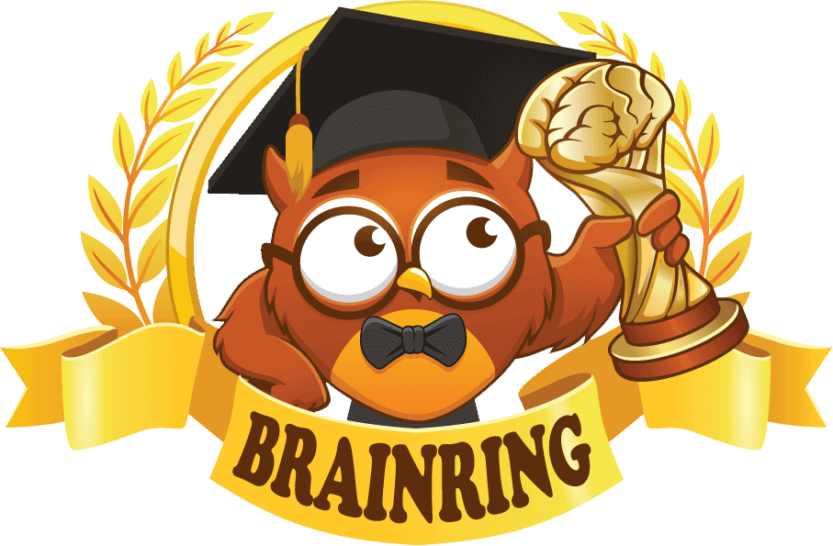
We invite pupils from age 5 to 16 to take a part in the Remote Online Educational Contest «BRAIN RING 2016 - Winter Session».
The competition is held 1-30 December 2016 on 8 subjects: Maths, English, Science, Computing, History, Physics, Biology and Geography.
The main objective is to increase interest and motivation in various subjects.
All learning materials and tasks are related to the current UK curriculum which provides contestants with the relevant knowledge during the competition by following the high learning standards for each subject.
All participants of the contest will receive a pen with the «BRAIN RING» logo printed on the side and the winners will be awarded medals, diplomas or certificates based on the achieved results.
Top prizes:
- A new Kindle e-Reader and 2 Amazon tablets
- 10 Brain Ring coupons for free participation in forthcoming contests
The contest materials will be available from 1 to 30 December 2016 on the brainring.co.uk website. We recommend that participating and performing the tasks during the competition is done during computer class. If this is not an option, contestants can do it at home at their own convenience.
The cost of participation per pupil for all competitions is:
- If participant is registered by a teacher or the school administration - £2.99
- If participant registers on his/her own) - £4.99
All interested pupils, without exception, are welcome to test their knowledge and get their brain in the game. All they need to do this is access to the internet!
To register and for more information please visit www.brainring.co.uk

